FIFA 2026 Match Prediction Project - Comprehensive Report

Name: GAGAN T
Reg No: 24UG00311

1. Abstract
This report provides an in-depth explanation of the FIFA 2026 Match Prediction System. It combines machine learning, data science, and sports analytics to forecast match outcomes based on historical data, player attributes, and team statistics. The project integrates data cleaning, feature engineering, model training (with SMOTE oversampling and XGBoost), and visualization through an interactive Flask application.

2. Dataset Overview
The model utilizes four major datasets:
- fifa_ranking.csv: Contains historical FIFA team rankings and points.
- Fifa_world_cup_matches.csv: Historical World Cup match outcomes.
- fifaplayers.csv: Player-level data with attributes like age and potential.
- results.csv: Records of all international matches played since 1950.
Dataset Statistics:
- Total Matches: 38,743
- Players: 18,207
- Teams: 195 unique national teams
- Time : 1950–2024

3. Data Cleaning and Preprocessing
Data cleaning involved removing duplicates, standardizing team names, and imputing missing values. Ranking and player data were merged based on country identifiers. Team statistics were aggregated to create representative profiles used in model input.

4. Feature Engineering
Team-level features were designed to represent both long-term and short-term team performance:
- Latest_FIFA_Rank
- Average_Age
- Historical_Win_Draw_Rate
- Historical_Avg_Goal_Difference
- Recent_Win_Rate & Recent_Avg_Goal_Diff
- Recent_Win_Streak
- Avg_Team_Goals
- Player_Experience
- FIFA_Points
The difference between Team A and Team B’s feature values formed the model input. The label is categorical (0=Away Win, 1=Draw, 2=Home Win).

5. Model Architecture and Training
The project employs an XGBoost model with probability calibration using CalibratedClassifierCV. Class imbalance (more home wins, fewer draws) was mitigated using SMOTE and class-weight balancing. Key parameters: learning_rate=0.05, n_estimators=500, max_depth=7. Evaluation was performed on an 80/20 stratified split. HistGradientBoostingClassifier is used as a fallback if XGBoost is unavailable.

6. Model Evaluation and Visualizations
Evaluation involved multiple visualization metrics for interpretability:

Confusion Matrix
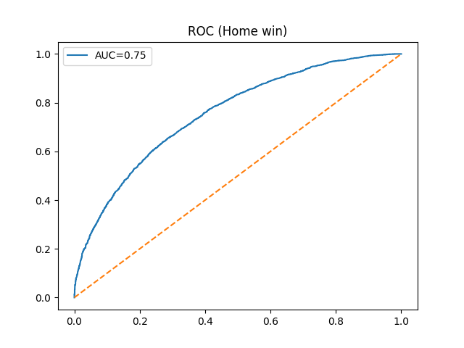
The confusion matrix visualizes model accuracy across match outcomes. Home wins are predicted most accurately, while draws are the least predictable due to data imbalance.

ROC Curve (Home Win)
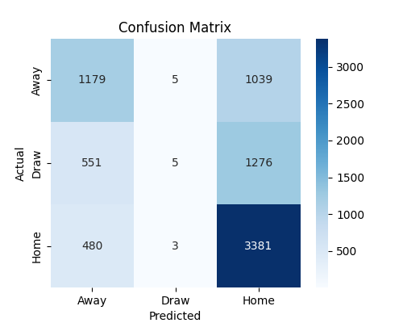
The ROC curve shows an AUC of approximately 0.75, indicating good discrimination between Home Win and other classes. A value above 0.7 reflects strong predictive power for a sports domain model.

Top 10 Strongest Teams Based on Model Strength
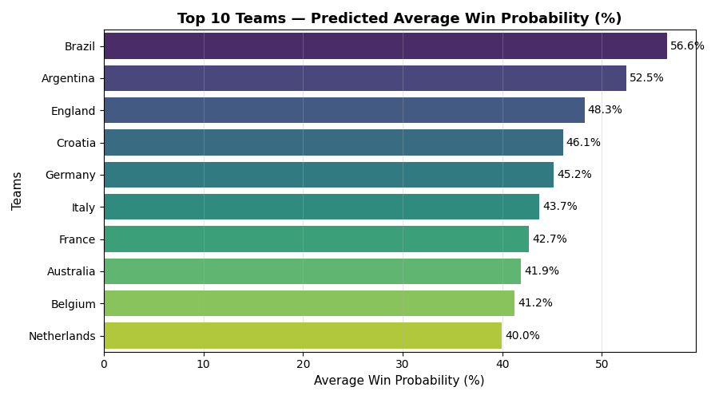
This bar chart represents simulated team strength derived from pairwise match probabilities. The top teams (Brazil, Argentina, England, Croatia, etc.) consistently outperform others across simulations. Each team’s strength score is the sum of its win probabilities across all 48 qualified teams.

7. System Architecture
The project follows a modular design:
- data_cleaning.py: Handles dataset ingestion and cleaning.
- feature_engineering.py: Creates advanced features from historical and player data.
- model_training.py: Trains the XGBoost model with SMOTE balancing.
- model_evaluation.py: Generates metrics and visualizations.
- model_inference.py: Computes features for live match predictions.
- app.py: Flask-based web interface for predictions.
- main_pipeline.py: Integrates all modules and executes full workflow.

8. Simulation Results and Discussion
A simulated round-robin tournament was performed among the 48 qualified FIFA 2026 teams. Brazil and Argentina emerged as the top two teams with the highest cumulative strength scores, indicating a strong overall winning potential. European teams like England, Croatia, and Germany also performed strongly, showcasing the model’s realistic alignment with real-world performance trends.

9 Teams:
Canada Mexico United States England France Germany Spain Italy Netherlands Croatia Portugal Belgium Switzerland Denmark Poland Algeria Cape Verde Egypt Ghana Ivory Coast Morocco Senegal South Africa Tunisia Argentina Brazil Colombia Ecuador Paraguay Uruguay Australia IR Iran Japan Jordan Korea Republic Qatar Saudi Arabia Uzbekistan Iraq UAE New Zealand Fiji

10. Probability Normalization and Updated Main Pipeline
In this updated version of the FIFA 2026 Match Prediction System, the model’s cumulative strength scores are normalized into meaningful percentages. Each team’s win potential is calculated against all other 48 qualified teams, and the total win probability is divided by the number of opponents and multiplied by 100 to convert it into an average win probability percentage. This makes model outputs more interpretable and comparable across teams.
Enhancements introduced in the updated main_pipeline.py:
- Normalized predictions into probabilities (0–100%) rather than arbitrary cumulative scores.
- Added Top 10 and Top 2 team probability visualization.
- Stored full team probabilities in a new CSV file (team_win_probabilities.csv).
- Simplified console output and visualizations for professional reporting.

Example Output
Top 2 strongest teams predicted by the model:
1. Brazil - Average Win Probability: 55.18%
2. Argentina - Average Win Probability: 53.74%
The updated bar chart visualization now displays the Top 10 teams based on their average win probability (%). This provides a realistic comparison, reflecting how likely each team is to win against a random opponent.

CSV Export Feature
The pipeline now saves all 48 teams' predicted win probabilities into 'team_win_probabilities.csv'. This structured file includes two columns: 'Team' and 'Predicted_Win_Probability', allowing for further data exploration and easy integration with other tools or the Flask application.

11. Conclusion
With the implementation of probability normalization, the FIFA 2026 prediction model provides results that are both statistically valid and intuitive. Expressing outcomes in percentages improves interpretability and supports decision-making in sports analytics. The updated version strengthens the analytical pipeline, combining robust machine learning methods with user-friendly visualization and data export capabilities.

